**Power BI Assignment 2**

1. Explain the advantages of Natural Queries in PowerBi with an example?

Natural language query is an attractive feature of Power BI. It allows the users to query the data by using natural language. This will be a faster and more custom way for the users. Additionally, the experience is interactive and fast due to Power BI’s in-memory storage. For example, if a user wants to find the total quantity sold, then the user can simply type “total quantity” in the Q&A. This will perform the sum operation on the “Quantity” column. This can be further understood from the below screenshot.

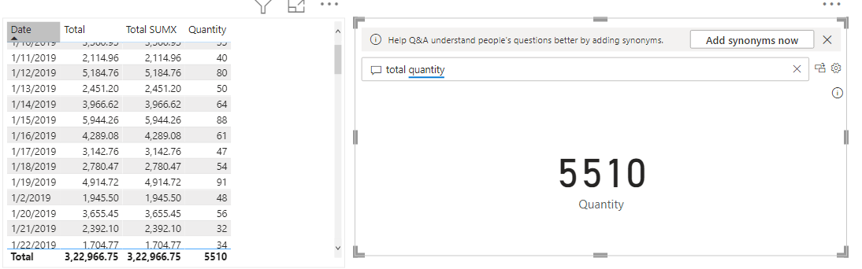

1. Explain Web Front End(WFE) cluster from Power BI Service Architecture?

The Power BI deployment consists of two clusters which are Web Front End (WFE) cluster, and a Back-End cluster. The WFE cluster manages the **initial connection and authentication process** for Power BI. It uses AAD (Azure Active Directory) to authenticate clients and provide tokens for subsequent client connections to the Power BI service.

1. Explain Back End cluster from Power BI Service Architecture?

The Power BI deployment consists of two clusters which are Web Front End (WFE) cluster, and a Back-End cluster. After WFE cluster, the Back-End cluster is how the authenticated clients interact with the Power BI service. The Back-End cluster **manages visualizations, user dashboards, datasets, reports, data storage, data connections, data refresh, and other aspects of interacting** with the Power BI service.

1. What ASP.NET component does in Power BI Service Architecture?

ASP.NET is used in the Web front end (WFE) cluster in the Power BI Service Architecture. It is used as server-side web application framework to produce dynamic web pages in the WFE cluster.

1. Compare Microsoft Excel and PowerBi Desktop on the following features:

**Data import:** Data import in excel has a limited number of sources from where data can be imported. However, apart from the sources available in excel there are multiple other data sources.

**Data transformation:** The transformation capabilities for both Excel and Power BI are almost same. i.e. the transformation which are done in Power BI can be achieved in Excel. However, Power BI has better user experience and optimized performance specific to data transformation.

**Modeling:** Modelling is possible in both the Excel and Power BI. However, Power BI has more features and user friendly when compared to the Excel.

**Reporting:** Reporting in excel involves lot of manual work. However, in Power BI it is very easy and reports can be created in lesser time with more functionalities.

**Server Deployment:** Deployment of excel sheets are very uncommon. Power BI reports and dashboards are usually deployed in the Power BI Service. After deployment they can be accessed by the shareholders.

**Convert Models:** Need more clarity

**Cost:** Excel comes as a package with the MS office suite. However, for Power BI the licensing cost is separate. For Power BI Pro the cost is 9.99 Dollars per user per month, for Power BI premium 20 dollars per user/per month or 4995 dollars per capacity per month.

1. List 20 data sources supported by Power Bi desktop.
2. Access database
3. IBM DB2
4. IBM Informix Database
5. IBM Netezza
6. SAP Business Warehouse Server
7. SAP HANA
8. Snowflake
9. Spark
10. SparkPost
11. SQL Server
12. Sybase
13. PostgreSQL
14. Azure Data Lake Storage Gen1
15. Azure Databricks
16. Google Analytics
17. Google BigQuery
18. Google Sheets
19. Excel
20. Amazon Athena
21. Amazon Redshift